Exercises: Client Side Rendering
Problems for exercises and homework for the "JavaScript Applications" course @ SoftUni.
Working with Remote Data
For the solution of some of the following tasks, you will need to use an up-to-date version of the local REST service, provided in the lesson’s resources archive. You can read the documentation here.
Each exercise must have package.json file with the following parameters:
"test": "mocha tests",
"start": "http-server -a localhost -p 3000 -P http://localhost:3000? -c-1"
Look package.json in previous lecture for example.

List Towns
You are given an input field with a button. In the input field you should enter elements separated by comma and whitespace (", "). Your task is to create a simple template that defines a list of towns. Each town comes from the input field. The list should be rendered inside the element with Id "root".

Screenshots
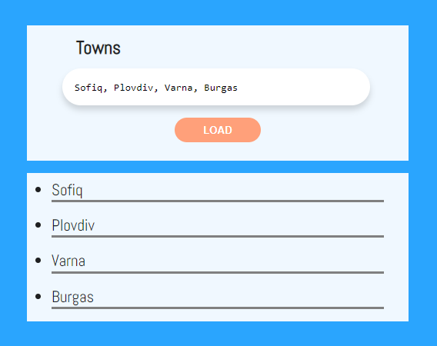
This is how the HTML should look like with the rendered template:
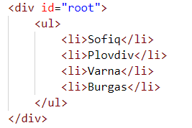

HTTP Status Cats
We all love cats. They are also a fun way to learn all the HTTP status codes.
Your task is to create a template to represent an HTTP cat card. After you have created the template, render all the cats into the section with id "allCats". Note that there should be a nested <ul> inside the section.
An HTTP cat has an id, statusCode, statusMessage and imageLocation. The cats are seeded using the function from the JS file named "catSeeder.js" – import this file as a module.
Each card block has a button that reveals its status code. You should toggle the button and change its text from "Show status code" to "Hide status code".
See the file example.html for an example of how the rendered HTML should look like.

Screenshots
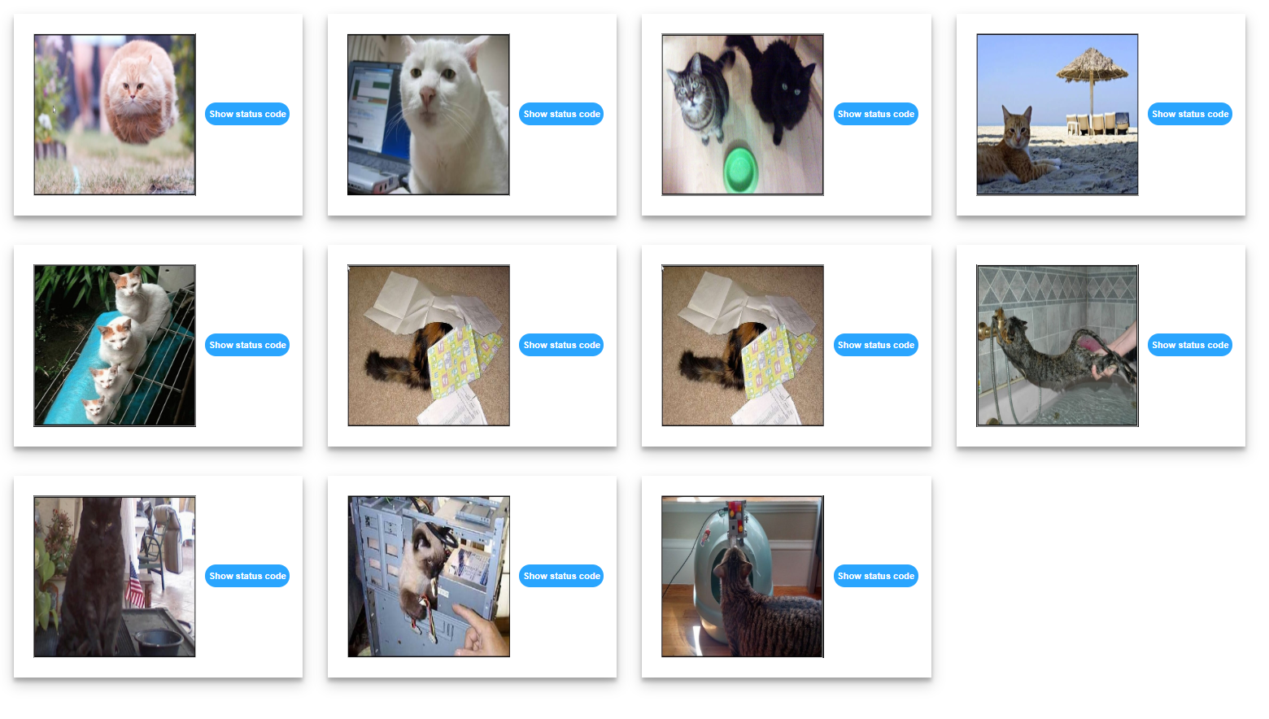
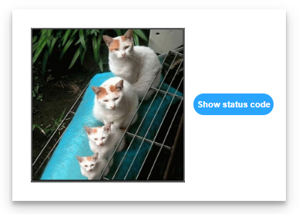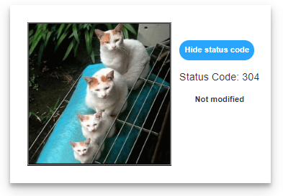

Search in List
An HTML page holds a list of towns, a search box and a [Search] button. Create a template for a list, containing all towns, that can be easily updated when the user performs a search. The list should be rendered inside the <div> element with id "towns". Load the values from the file towns.js, which you can import as a module.
Implement the search function to apply class "active" to the items from the list which include the text from the search box. Also print the number of items the current search matches in the format "<matches> matches found". The search should be case-sensitive.
See the file example.html for an example of how the rendered HTML should look like.

Screenshots
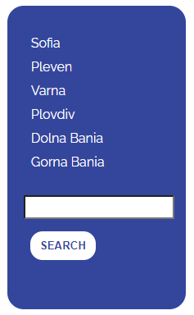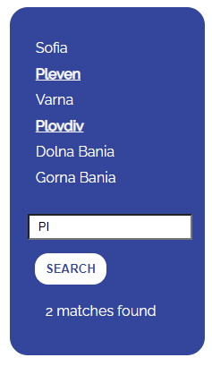

Fill Dropdown
Create functionality that loads list items from a remote service and displays them inside a drop-down menu. The user should also be able to add new items to the service by entering them in the input field on the page and submitting the form. Create a template for the drop-down list and the items inside it that can be easily updated with new entries.
When the program starts, the data should be automatically retrieved from the server via GET request from URL http://localhost:3030/jsonstore/advanced/dropdown and rendered as <option> items inside the <select> with id "menu". Upon form submission, send a POST request to the same URL and if it is successful, update the list of options with the newly created item.
Each item has a property text entered by the user and _id, which is generated by the server. When creating the HTML elements, use the _id as option value and text as option textContent.

Example
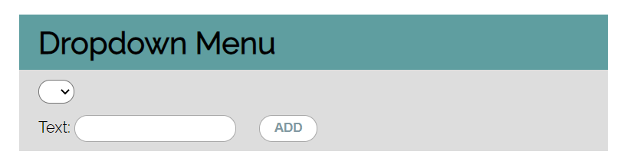
This is how the rendered HTML should look like:
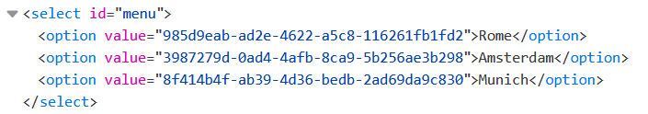

Table – Search Engine
Write a function that searches in a table by given input. Create a template for a table row, which can be easily updated with class values when the user performs a search. Load the data from the following URL with a GET request: http://localhost:3030/jsonstore/advanced/table
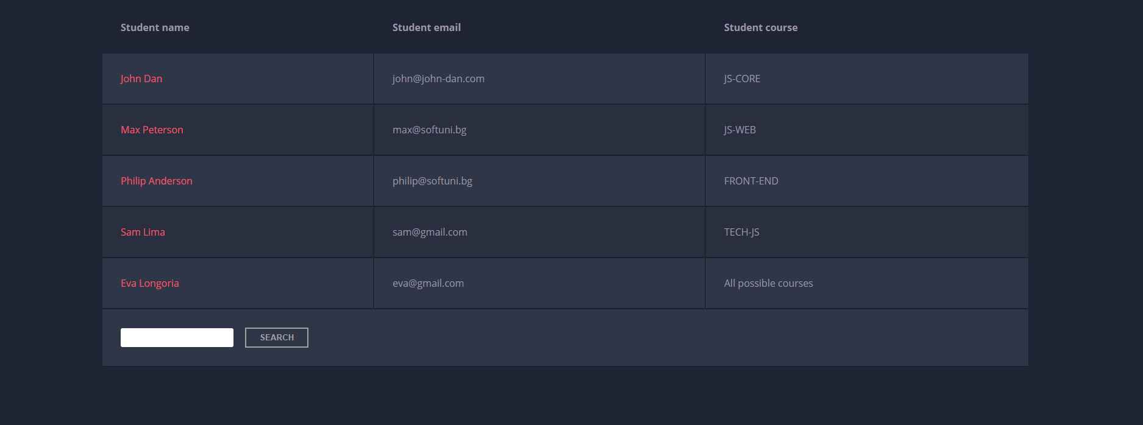
When the "Search" button is clicked, go through all cells in the table body and check if the given input is included anywhere. The search should be case-insensitive.
If any of the rows contains the submitted string, add a select class to that row. Note that more than one row may contain the given string. If there is no match nothing should be highlighted.
Note: After every search, clear the input field and remove all already selected classes (if any) from the previous search, in order for the new search to contain only the new result.
See the file example.html for an example of how the rendered HTML should look like.

Example
For instance, if we try to find eva:
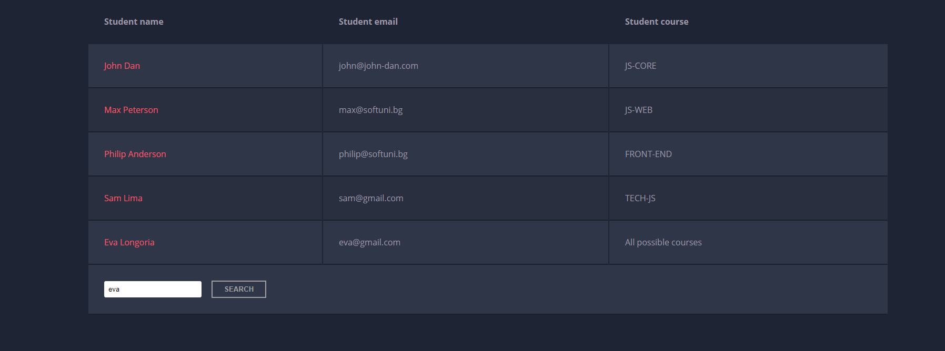
The result should be:
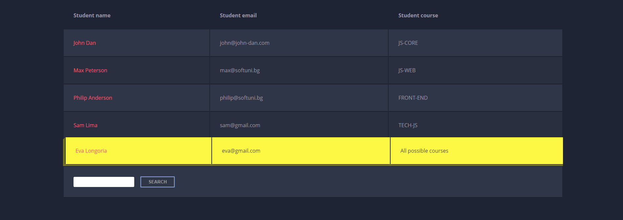
If we try to find all students who have email addresses in softuni domain, the expected result should be:
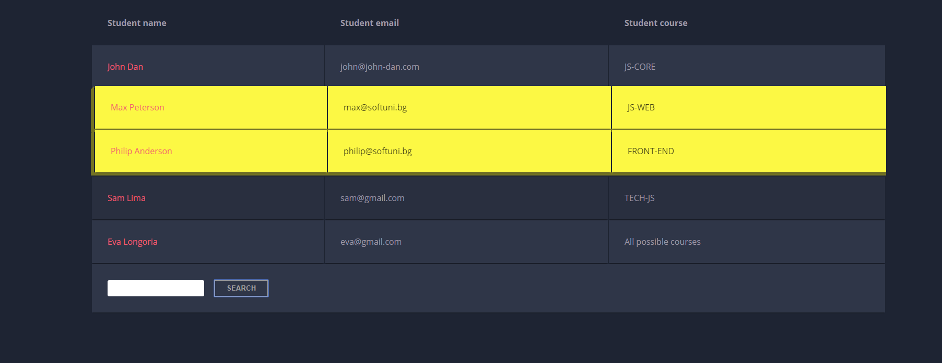

Book Library
Create templates for all items on the page, as you see fit. See the file example.html for an example of how the rendered HTML may look like. You are free to add attributes that would help you implement the required functionality.

Get All Books
First task is to "GET" all books when the button "Load All Books" is clicked. To consume the data from the API, send a request to the following URL: http://localhost:3030/jsonstore/collections/books
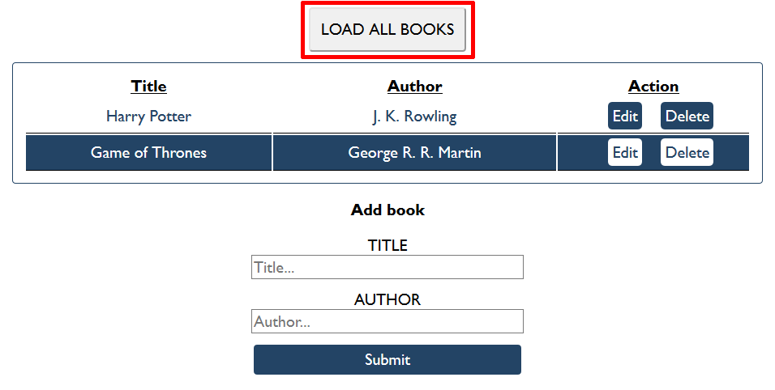

Create Book
Initially, the form with id "add-form" should be displayed. Write functionality to create a new book, when the submit button is clicked. Before sending the request be sure the fields are not empty (make validation of the input). To create a book, you must send a "POST" request and the JSON body should be in the following format:
{
"author": "New Author",
"title": "New Title"
}

Get Book
Send a "GET" request to the following url:
http://localhost:3030/jsonstore/collections/books/:id

Update Book
By clicking the edit button of a book, display the form with id "edit-form" and populate its fields with the information from the selected book:
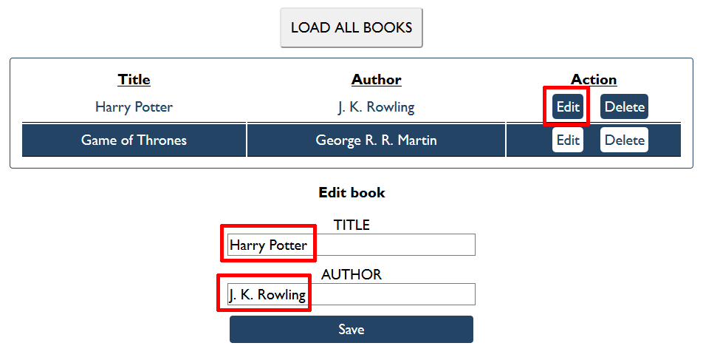

The HTTP command "PUT" modifies an existing HTTP resource. The URL is:
http://localhost:3030/jsonstore/collections/books/:id
The JSON body should be in the following format:
{
"author": "Changed Author",
"title": "Changed Title"
}

Submitting Your Solution
Place in a ZIP file the content of the given resources including your solution. Exclude the node_modules folder if there is one. Upload the archive to Judge.
